1. Design FIFO

Tuesday, April 22, 2025

1:54 PM

1. Specification

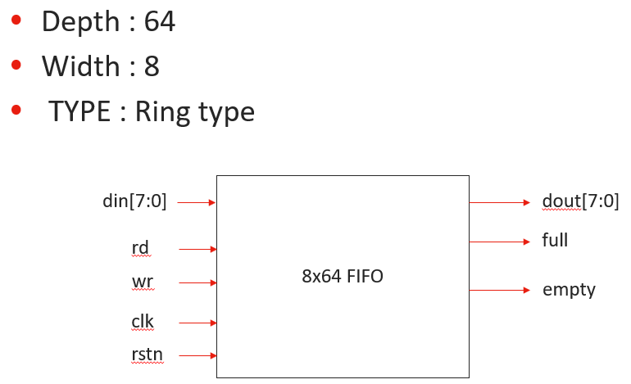

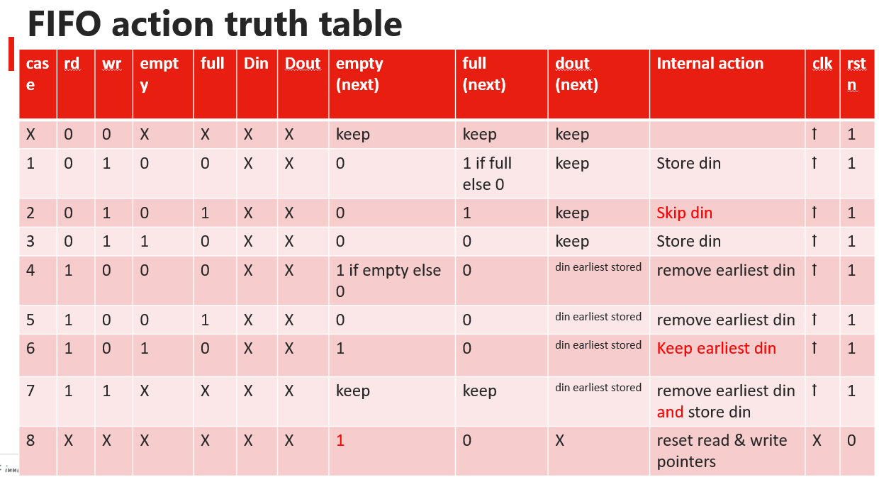

1. FIFO state (dout, full, empty etc.) updates only at positive edge of clk or rstn low

Both full and empty are 1 is not allowed

實作一個FIFO，需要哪些東西 :

1. wptr, rptr推進
2. 宣告queue存內容
3. 檢查空 & 滿 (什麼時候檢查，push & pop)  
   怎麼判斷滿? e.g. wptr =63, rptr = 0;   
   if (wptr > rptr) num = wptr - rptr + 1

# 碰到的問題

|  |  |
| --- | --- |
|  |  |
|  | 使用modport時，不需要再用input logic這些字眼，直接input即可 |
|  | 常數要放後面 |

|  |  |  |  |
| --- | --- | --- | --- |
| interface | top | module | test bench |
|  |  |  |  |

# 處理wrap問題

1. 後續發現pop之後，pop的那個位置整個東西不見，導致rptr & idx對不上 => 原本若使用queue，會整個資料結構往前推移，改用靜態array實現。
2. 使用reference model確認正確性

|  |  |
| --- | --- |
| 問題 | Code |
|  |  |

# 設計Reference Model

1. 設計邏輯 :  
   A. 用Line 1的ifdef隔開，可以選擇要不要開ref model，可以在xrun時加上+define+USE_REF_MODEL  
   B. 增加compare function，做wptr / rptr / push data / pop data的檢查  
   C. race condition避免，預期是在每次posedge推完/拉完做檢查，但發現如果沒delay的話，可能還沒推入FIFO就檢查了，所以code的部分延遲一個time unit再做檢查。

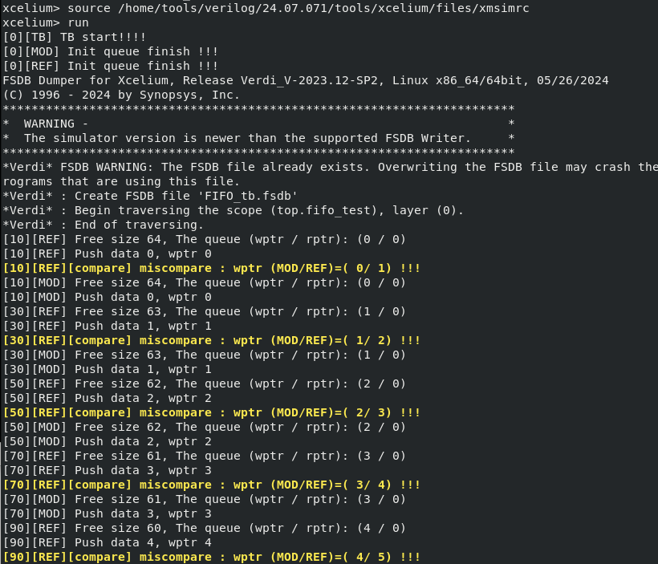

|  |  |
| --- | --- |
| ref_model |  |
|  |  |

# 設計Random Pattern

針對了wr / rd / din / dout做random

# 設計covergroup

|  |  |  |
| --- | --- | --- |
| Log | Code | Coverage |
|  |  | bus_din, bus_dout的寬度為1 byte，資料範圍為0-255，但分bin會每4個值分成一個bin (e.g. 0~3, 4~7) |
|  |  | 改成1個值，1個bin後，且調高ramdon次數後，有達到100% coverage在每個值內 |

# 轉化成agent

1. 轉成write agent, read agent, rstn agent,

理由 :

|  |  |  |
| --- | --- | --- |
| **傳統設計 (module風格)** | **轉成class-based設計 (agent/env風格)** | **說明** |
| tb.sv | tb.sv | 仍然需要，但只剩很薄的一層，主要是 new env 然後 run |
| top.sv | 有些環境還是叫 top.sv，或者直接就是 tb.sv 包起來 | 通常 top 變成只包一個interface和 DUT 例化 |
| 手動寫 stimulus | agent.run() 自己自動送 stimulus | 測試輸入（stimulus）自動化、模組化了 |
| 手動寫結果比對 | ReferenceModel 比對結果 | 驗證正確性由 class 控制，與 DUT 比對 |
| 沒有 coverage 或用基本 assertion | 有內建 covergroup 和 scoreboard | 有功能覆蓋率 (functional coverage) 的蒐集 |

1. 進度，會被compare的異常狀態卡住。

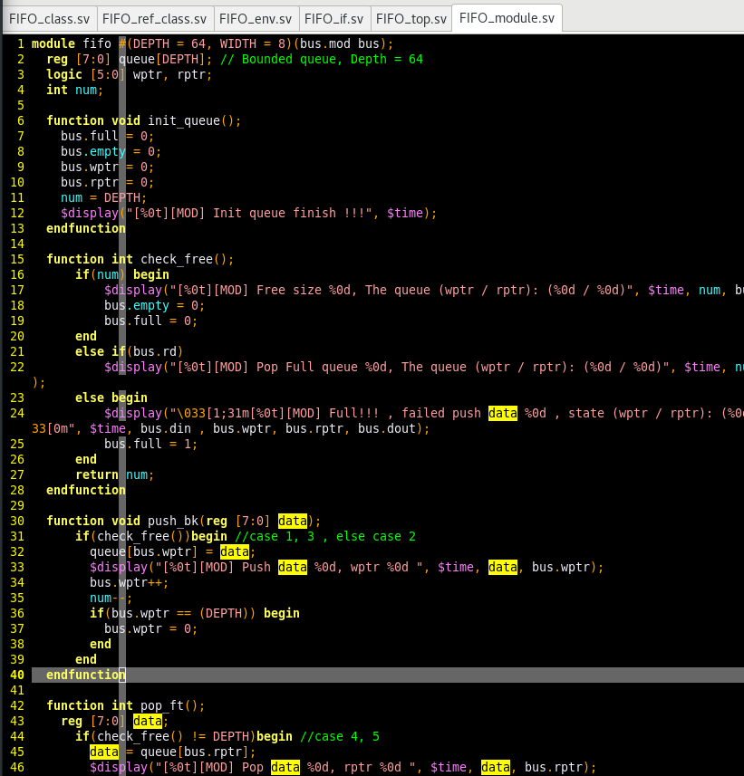

//禮拜五

# 轉成queue reference model

1. 把log弄得更好理解
2. 確認truth table (module / ref)  
   把truth table弄成測試mode
3. 確認cross coverage
4. coverage 100%
5. 測試模式 (fast w/slow r)

case 1 (wr = 1，把din存進array)

|  |  |  |  |  |  |  |  |  |  |  |  |  |
| --- | --- | --- | --- | --- | --- | --- | --- | --- | --- | --- | --- | --- |
| **case** | **rd** | **wr** | **empty** | **full** | **Din** | **Dout** | **empty**  **(next)** | **full**  **(next)** | **dout**  **(next)** | **Internal action** | **clk** | **rstn** |
| **1** | **0** | **1** | **0** | **0** | **X** | **X** | **0** | **1 if full else 0** | **keep** | **Store din** | ꝉ | 1 |

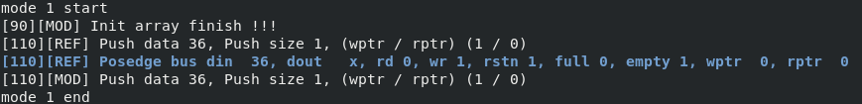

case 2 (wr = 1，把array存滿，滿了之後 不能再繼續存)

|  |  |  |  |  |  |  |  |  |  |  |  |  |
| --- | --- | --- | --- | --- | --- | --- | --- | --- | --- | --- | --- | --- |
| **case** | **rd** | **wr** | **empty** | **full** | **Din** | **Dout** | **empty**  **(next)** | **full**  **(next)** | **dout**  **(next)** | **Internal action** | **clk** | **rstn** |
| **2** | **0** | **1** | **0** | **1** | **X** | **X** | **0** | **1** | **keep** | **Skip din** | ꝉ | 1 |

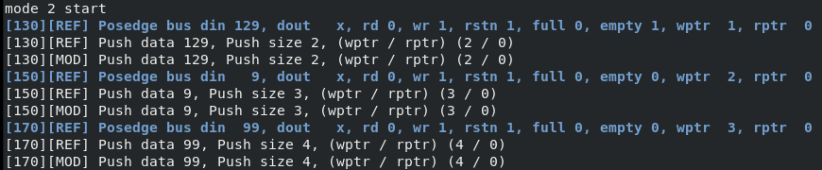

….

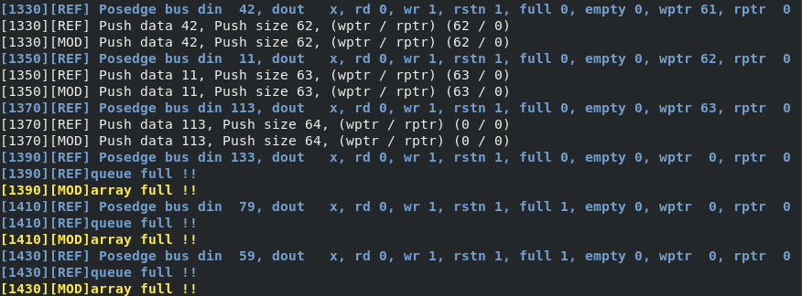

case 3 (wr = 1，empty的時候跟case1一樣直接存入)

|  |  |  |  |  |  |  |  |  |  |  |  |  |
| --- | --- | --- | --- | --- | --- | --- | --- | --- | --- | --- | --- | --- |
| **case** | **rd** | **wr** | **empty** | **full** | **Din** | **Dout** | **empty**  **(next)** | **full**  **(next)** | **dout**  **(next)** | **Internal action** | **clk** | **rstn** |
| **3** | **0** | **1** | **1** | **0** | **X** | **X** | **0** | **0** | **keep** | **Store din** | ꝉ | 1 |

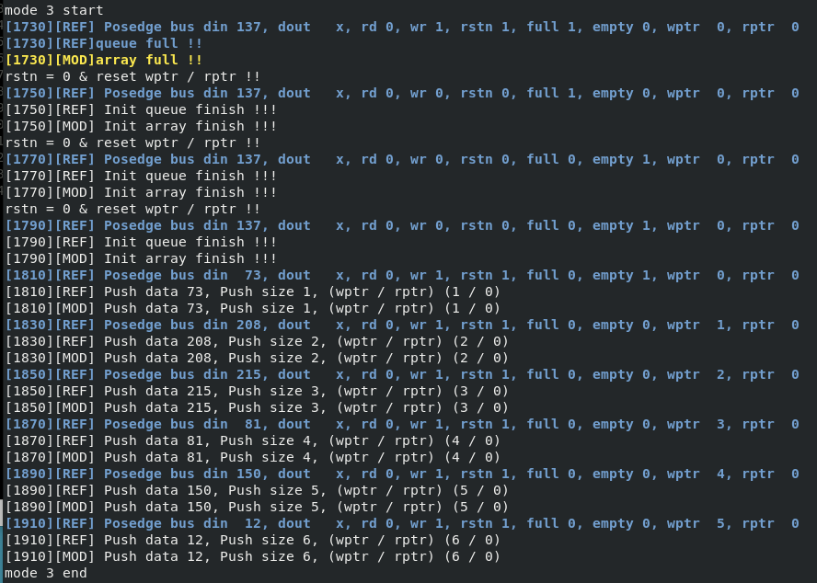

case 4 (rd = 1，queue裡面有東西可以直接pop)

|  |  |  |  |  |  |  |  |  |  |  |  |  |
| --- | --- | --- | --- | --- | --- | --- | --- | --- | --- | --- | --- | --- |
| **case** | **rd** | **wr** | **empty** | **full** | **Din** | **Dout** | **empty**  **(next)** | **full**  **(next)** | **dout**  **(next)** | **Internal action** | **clk** | **rstn** |
| **4** | **1** | **0** | **0** | **0** | **X** | **X** | **1 if empty else 0** | **0** | **din earliest stored** | **remove earliest din** | ꝉ | 1 |

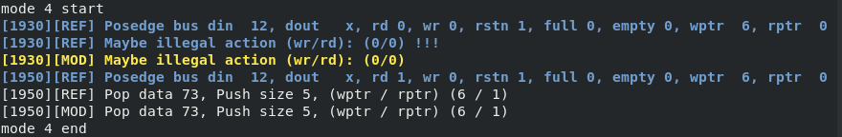

case 5 (rd = 1，queue若是滿的也是可以直接pop)

|  |  |  |  |  |  |  |  |  |  |  |  |  |
| --- | --- | --- | --- | --- | --- | --- | --- | --- | --- | --- | --- | --- |
| **case** | **rd** | **wr** | **empty** | **full** | **Din** | **Dout** | **empty**  **(next)** | **full**  **(next)** | **dout**  **(next)** | **Internal action** | **clk** | **rstn** |
| **5** | **1** | **0** | **0** | **1** | **X** | **X** | **0** | **0** | **din earliest stored** | **remove earliest din** | ꝉ | 1 |

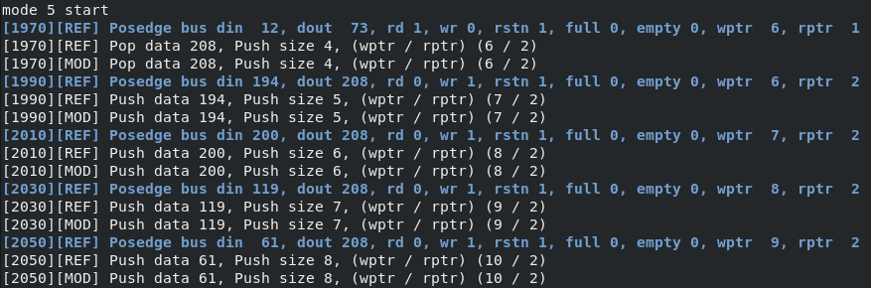

….

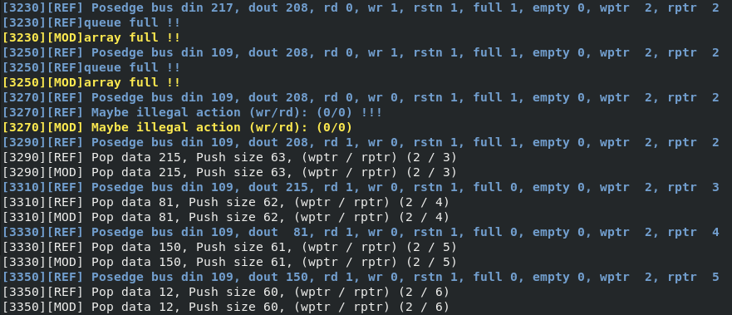

case 6 (rd = 1，空的queue不能pop東西)

|  |  |  |  |  |  |  |  |  |  |  |  |  |
| --- | --- | --- | --- | --- | --- | --- | --- | --- | --- | --- | --- | --- |
| **case** | **rd** | **wr** | **empty** | **full** | **Din** | **Dout** | **empty**  **(next)** | **full**  **(next)** | **dout**  **(next)** | **Internal action** | **clk** | **rstn** |
| **6** | **1** | **0** | **1** | **0** | **X** | **X** | **1** | **0** | **din earliest stored** | **Keep earliest din** | ꝉ | 1 |

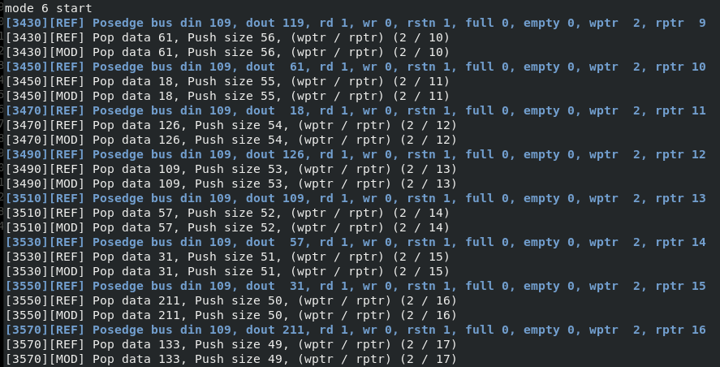

…

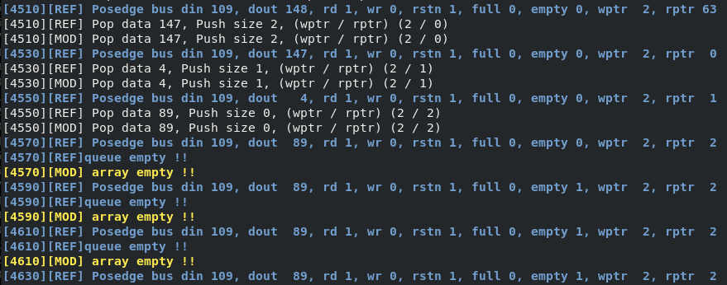

case 7 (wr / rd = 1，同時Push/Pop)

|  |  |  |  |  |  |  |  |  |  |  |  |  |
| --- | --- | --- | --- | --- | --- | --- | --- | --- | --- | --- | --- | --- |
| **case** | **rd** | **wr** | **empty** | **full** | **Din** | **Dout** | **empty**  **(next)** | **full**  **(next)** | **dout**  **(next)** | **Internal action** | **clk** | **rstn** |
| **7** | **1** | **1** | **X** | **X** | **X** | **X** | **keep** | **keep** | **din earliest stored** | **remove earliest din and store din** | ꝉ | 1 |

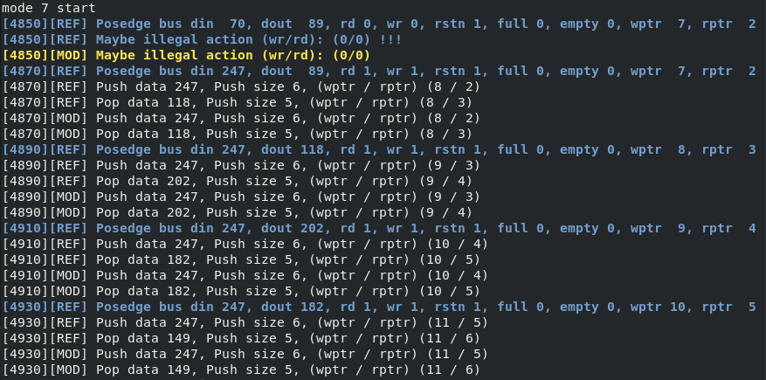

case 8 (rstn = 0，清掉wptr / rptr / 內部元素)

|  |  |  |  |  |  |  |  |  |  |  |  |  |
| --- | --- | --- | --- | --- | --- | --- | --- | --- | --- | --- | --- | --- |
| **case** | **rd** | **wr** | **empty** | **full** | **Din** | **Dout** | **empty**  **(next)** | **full**  **(next)** | **dout**  **(next)** | **Internal action** | **clk** | **rstn** |
| **8** | **X** | **X** | **X** | **X** | **X** | **X** | **1** | **0** | **X** | **reset read & write pointers** | X | 0 |

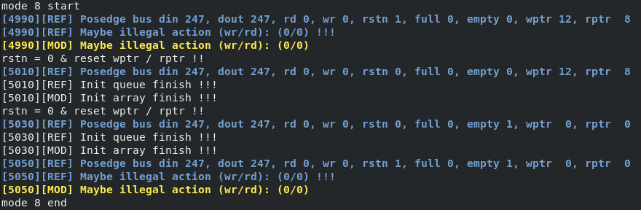

Coverage問題 (實際上coverage沒打滿)

|  |  |  |
| --- | --- | --- |
|  | 在get coverage的時候要用浮點數 |  |
|  |  | 有dist的無法使用randc的變數 |
| 成功的版本 | 成功的版本 | 針對wr / rd兩種case  都有打滿ptr深度 64 * data寬度256 = 16384種組合都覆蓋了。 |